 | Weekly Team Task Report | #2

Team: GeoLearn |  |  |  |  |  | Date: 1/28/2020
Project Title: Improving elementary education with custom online enironmental science lectures

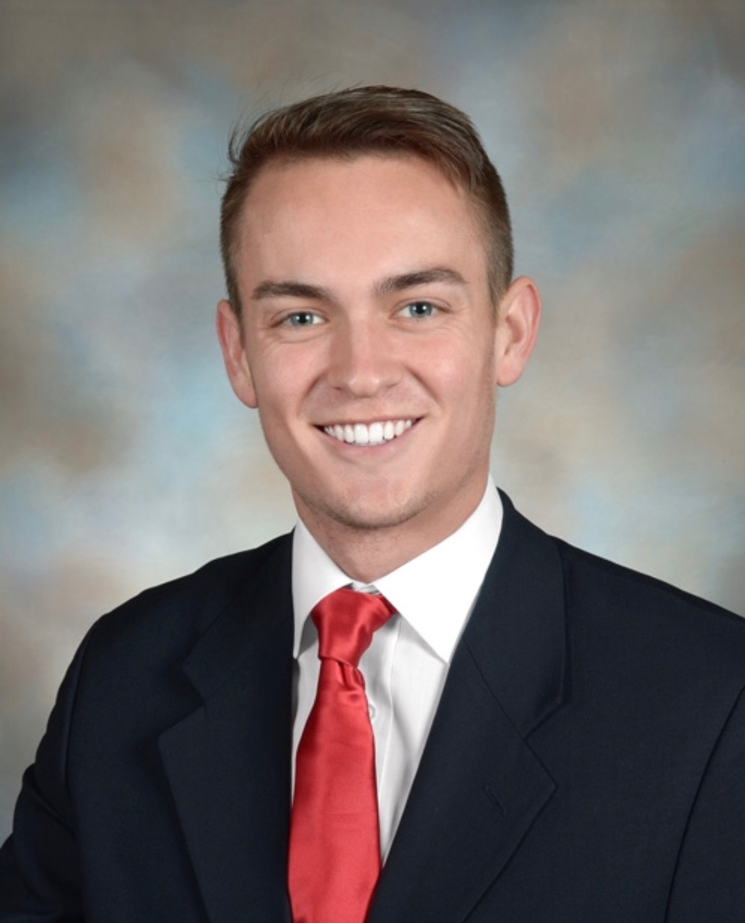 | Samuel Prassse  Present  On-time | 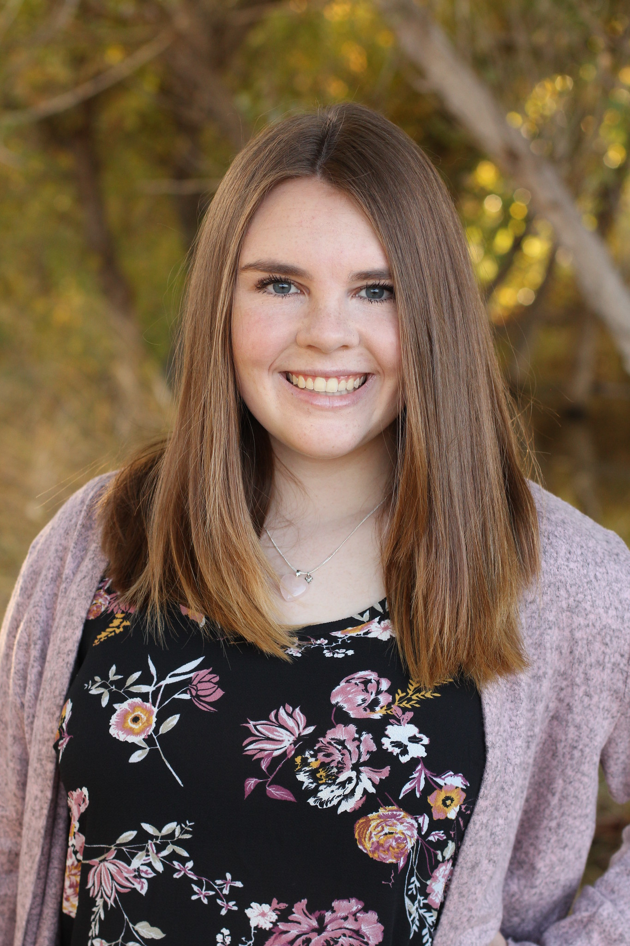 | Kaitlyn Grubb  Present  On-time | 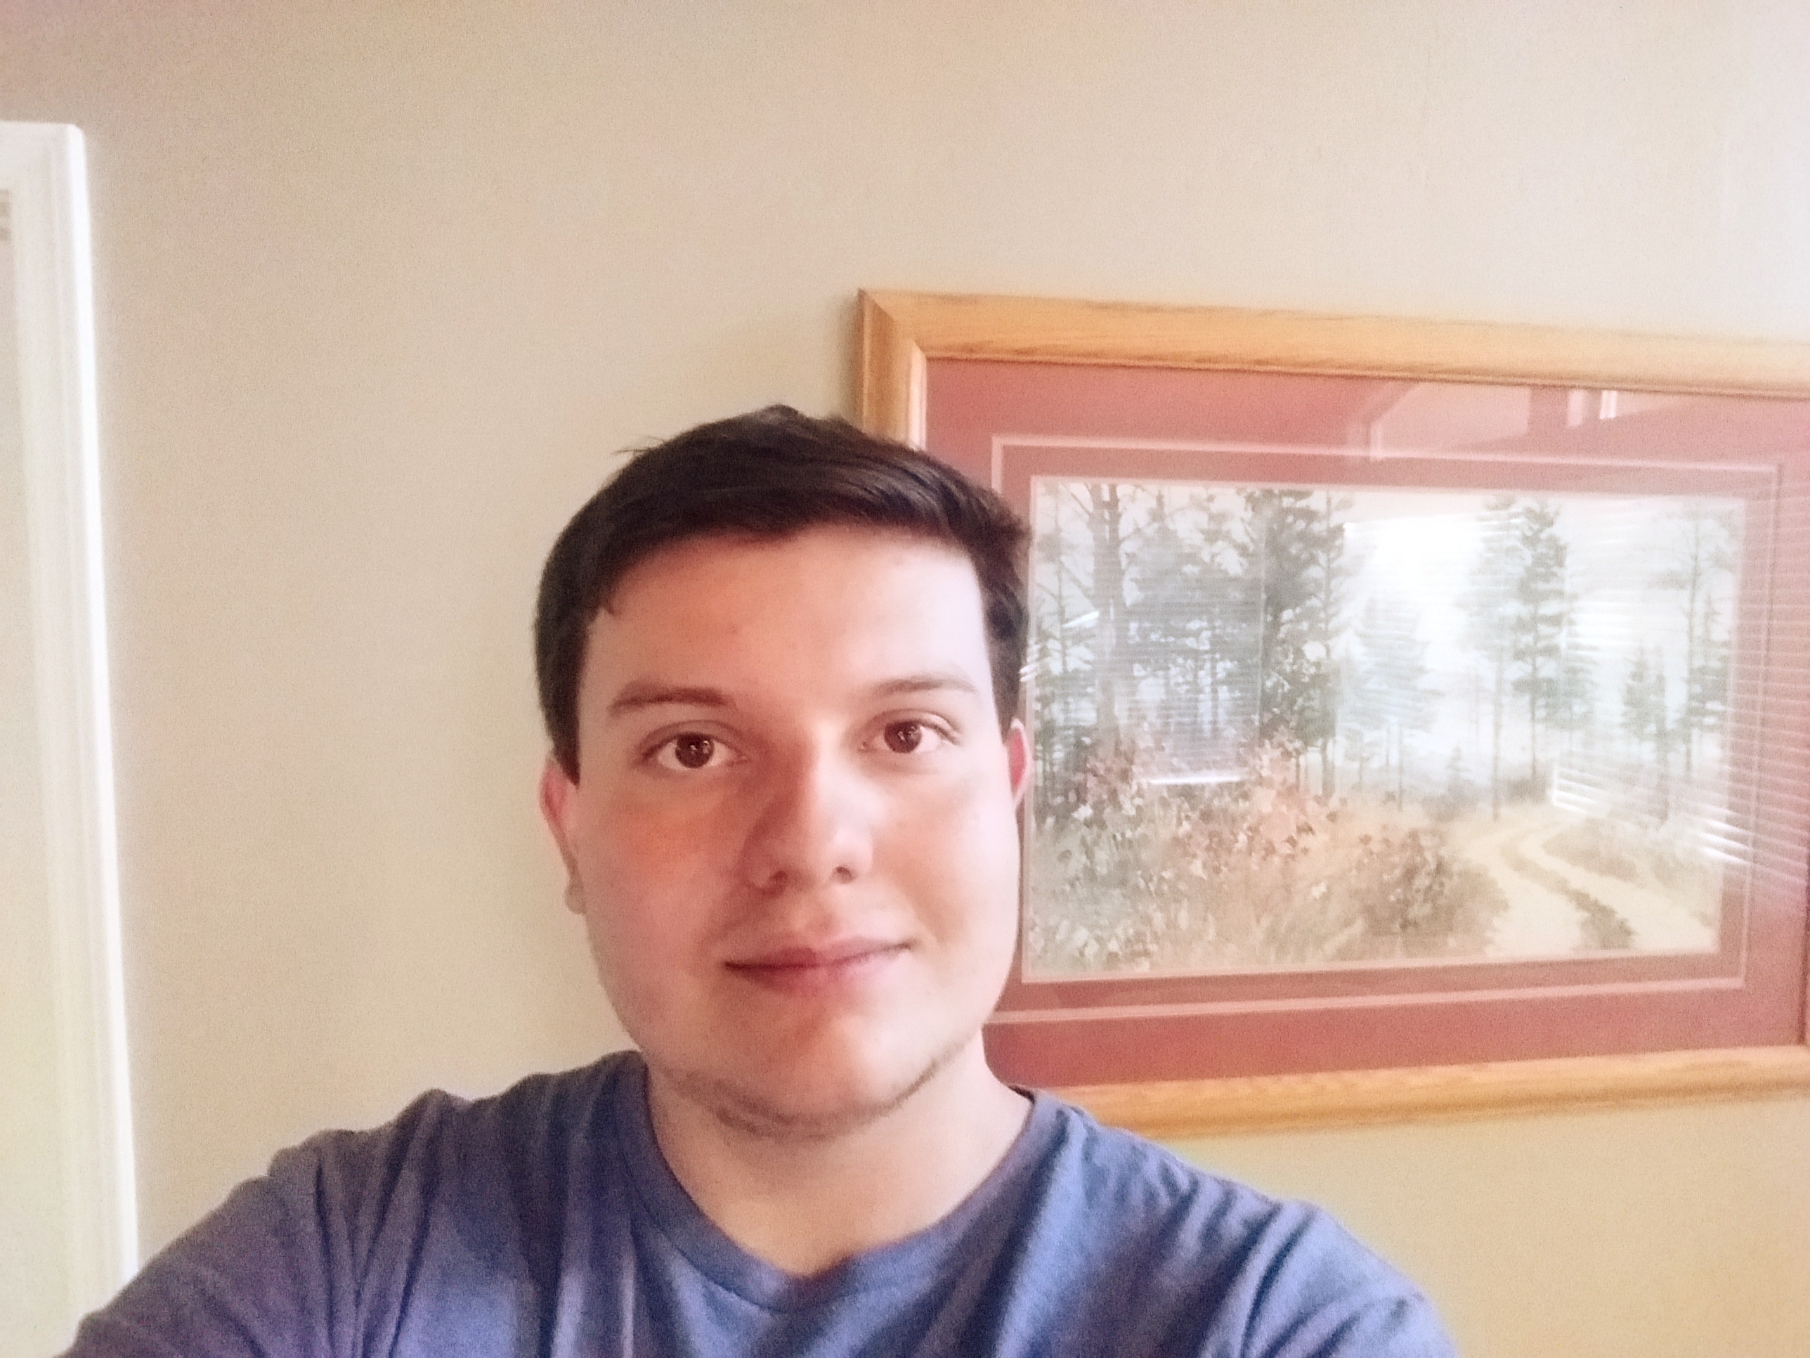 | Tyler Pehringer  Present  On-time |  | 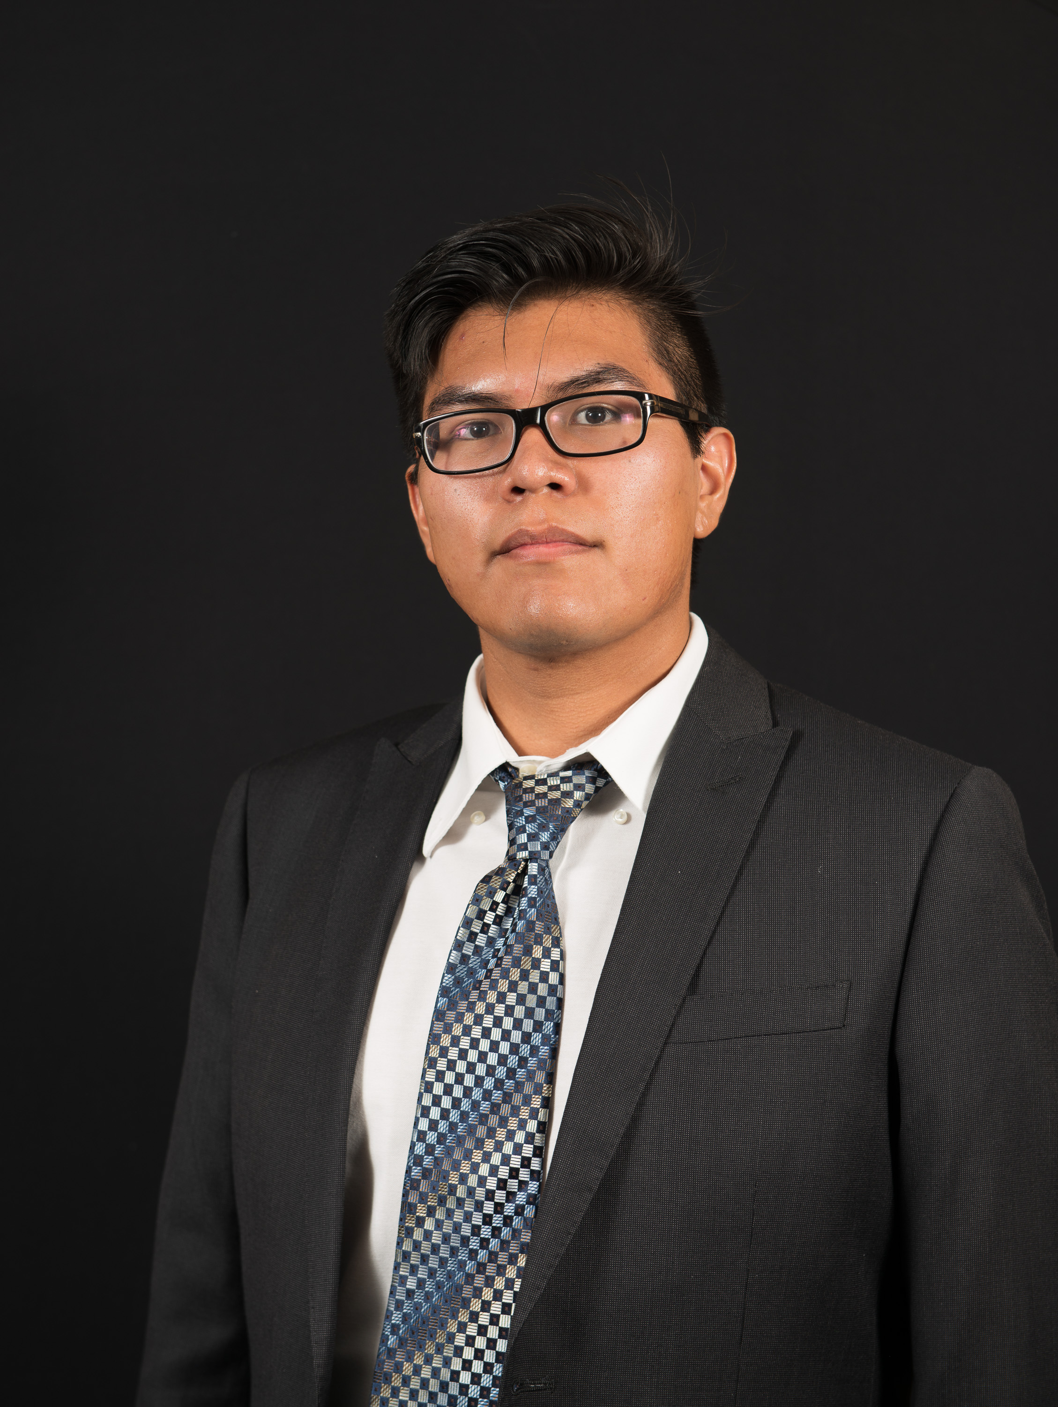 | Joshus Tenakhongva  Present  On-time

Recent Meetings:
- General Team Meeting
- Sponsor Meeting

TASKS COMPLETED since last meeting:

Task Title: Developed schedule with mentor for the semester | Task Initiation: 1/23 | Orig. Due Date: 1/23 | Status: Completed
Who (%): Team (100%)
Description: The team met with Dr. Doughty last week to discuss our expecteations for the semester. We have decided to have our separate pieces of the project together by the following Thursday, 2/6. This will be our MVP and we can move forward from there. By 2/20, we will have a product that is able to create four different types of presentations. Tyler is building the website, Samuel is working on earth engine information, Kaitlyn is working on slide creation, and Joshus is working on the Ecolocation database.
Expected Outcome: MVP with 4 types of presentations.

This week’s Tasks: Work plan for coming week
Task Title: Refine Presentation | Task Initiation: 1/16 | Orig. Due Date: 1/31 | Status: In Progress
Who (%): Team (100%)
Description: The team will meet again next week to refine different parts of the presentation. We felt there were parts that needed to be developed more such as slide information and meaningful graphics, and the information that was spoken in the presentation.
Expected Outcome: We expect to have the cleanest and most well put together presentation out of all the capstone groups.

Task Title: Slideshow Creation | Task Initiation: 1/30 | Orig. Due Date: 2/6 | Status: In Progress
Who (%): Kaitlyn (50%), Samuel (50%)
Description: Kaitlyn is working on taking the data that Samuel has pulled from Google Earth Engine and placing it into our slideshow presentation. She is also creating an automated version of the slides that Dr. Doughty and team have created for us to implement.
Expected Outcome: Exact replicas of presentations given to us by Dr. Doughty.

Task Title: Website Creation | Task Initiation: 1/23 | Orig. Due Date: 2/6 | Status: In Progress
Who (%): Tyler (100%)
Description: Tyler is working on building the base website in which the team can combine each section of the project. The general website design is still in the works but we intend to have a local server to test our code on and develop the rest of the project.
Expected Outcome: Working website that looks clean and well put together. Site needs to have working parts by next weeks sponsor meeting.

Task Title: Ecolocation Data | Task Initiation: 1/23 | Orig. Due Date: 2/6 | Status: In Progress
Who (%): Joshus (100%)
Description: Joshus is working closely with Roo and Dr. Doughty to develop the Ecolcation aspect of our project. We will be gathering pictures from the web and storing them either locally or in the cloud for every animal in the database. This information will be used for most pictures we use in our slideshow presentations.
Expected Outcome: Working website that looks clean and well put together. Site needs to have working parts by next weeks sponsor meeting.

Upcoming Tasks: Planning
Task Title: Prototype Demo Milestone | Who (%): Team (100%) | Rough Due Date: 3/4
Description: Fully functioning prototype demonstration.

Task Title: Software Design Document | Who (%): Team (100%) | Due Date: 2/8
Description: This document is a description of our projects overall architechtural design as well as the design of each major module. It is being called, “the blueprint of our final product”. Draft is due to Fabio by Friday of week 2/4.

Other Problems / Other Issues:
- What types of graphics to include on slides.
- Mostly slide conversations today.
- “Tree” graph that Kaitlyn is creating; feedback.

TASK REPORT INSTRUCTIONS

Overview: The task report is a critical tool for tracking team status over the course of the project, and is a concept widely used (though exact form differs) in professional practice in managing project teams. It is useful for both the project mentor/supervisor and for the team: For the supervisor, it provides continuous insight into the progress the team is making, as well who is contributing what to team output. For the team, it is a valuable communication tool, making very clear and explicit what tasks needed to be done, who was supposed to do them…and whether that person(s) is performing well.

Filling out the Task Report
Filling out the task report is designed to be relatively low overhead, by making it mostly an operation of copy-paste, with appropriate updating. The team should plan to meet each week, shortly before their mentor meeting to discuss existing tasks to update the task report accurately, as well as to negotiate tasks/assignments to list for the coming week.

Things to do just once.
The first thing to do is to customize your task report for your team. Fill in the items shown in red in the header area: team name and logo, project title, plus names and small (50x50 pixel or so) headshots of all team members. SAVE THIS OFF to use as your template for the whole year.

What to do every week, before your mentor meeting:
Meet as a team before your mentor meeting to discuss tasks and create new task report.
A. Getting started. The first thing to do is to open your task report from *last week* and save it off as a new file. This is how the overhead stays low: you make every week’s report by editing/updating the one from last week! Checklist:
- Update the report number at top right: counts up by one each week
- Update the date to show correct date for mentor meeting.
- Bullet out your meetings in the last week, either team internal or with client. Do not list your mentor meeting.
B. Update Status on tasks tackled in past week.
Start with last week’s task report. Review all tasks assigned for last week. Hopefully you will assign them a status of “complete” and move them to “TASKS COMPLETED” in the current task report you are creating.
If a task was not completed, show its percentage complete in the STATUS field. If it is past its due date, also add the work “OVERDUE” to the percentage shown in STATUS.
C. Plan and assign tasks for coming week
Next turn your attention to the coming week. Discuss workload and create specific tasks that should be completed. This means copy-pasting an empty copy of a task table, into the “COMING WEEK plan” area, and filling it out. Please observe the following:
- Task title: is just a short 2-5 word title for the task, e.g., “Implement database updating”.
- Task initiation: is the date that you create/assign the task. Never changed after creation.
- Task due date: is the date that you set for task completion. This states clearly when you expect the task to be completed.
- Status: starts out “in progress” and 0% done. Hopefully the next status will be “complete” and 100% as you move it to the “TASKS COMPLETED” section next week. But if a task slips, it stays in “THIS WEEK” and the completion percentage is shown. If it passes the due date, it’s status becomes “OVERDUE”.
- Who: States who is responsible for the task. If there are multiple people responsible for it, it shows the percentage of responsibility/contribution of each.
- Description: Elaborates on the short task title by giving a brief 2-3 sentence description. For the “database updating” task title mentioned above, it might be “Explore API between MyFrameWork and our PostgreSQL database, and implement reliable update of our client records”
- Expected Outcome: Succintly describes exactly what deliverable(s) you expect to see at completion. For our example this might be “A simple web page that opens to show all current records, allows user to select a record and enter an updated value for some field. After submit, the page refreshes to show the updated database”. See? Avoids misunderstandings about what completing the task means.

VITAL POINTERS regarding tasks:
- Your tasks should be small and detailed enough to complete in a week. It’s useless to list “do the user interface” as a task, with a deadline four weeks out! You should rarely have tasks that span more than a week. If a task seems longer than a week, split it into task:partA and task:partB, each a week long and showing what you expect done after each week.
- Avoid assigning tasks to multiple people when possible. If a task is big, split it into task:PartA, taskPartB etc, with each of these subtasks and expected outcomes detailed. If you do have to list multiple people, try to specify what contributions/outcomes are expected for each.
- You should typically aim to have each team member assigned to one or more tasks each week. If you don’t, then something is broken with your teaming process!

D. Finish up last task report details
You’re almost done! Now just fill out the last sections of the task report.
- Upcoming Tasks: Just list larger tasks that you see on the horizon, e.g., “Draft of feasibility report” or “Design Review II”. The idea is just to be explicitly aware of larger tasks/deadlines coming up in the next weeks. These can be quite large-grained; they will be broken into subtasks and assigned when you get to them.
- Other problems/Issues: This is just a great place to note down any issues/problems/misunderstandings that happened…and that you might want to capture or discuss with your mentor at the meeting.

